**Biometrics**

**Assignment - 2**

**Submitted by Karan Shah, Tina Shin and Santhosh Subramanian**

Design Analysis:

* Enrolled data(Gallery) has from LG2200-2008-03-11\_13 folder.
* Probe 1 and Probe 2 are set of images from two different data sets (LG400 and LG2200) taken from the year 2010-04-27\_29.
* Used matlab code to get all the template and mask values of enrolled images.
* Formed four 3D(m\*n\*p) array from the given data.
  + templateEnrolledArray (20\*480\*1056)
  + maskEnrolledArray (20 \* 480 \* 1056)
  + templateProbeArray (20 \* 480 \* 120)
  + maskProbeArray (20 \* 480 \* 120)

m & n are the number of rows and colums for the template and mask of each image.

p - total number of images in all the folders

For Probe, we have considered only 10 folders (all the images in those 10 folders).

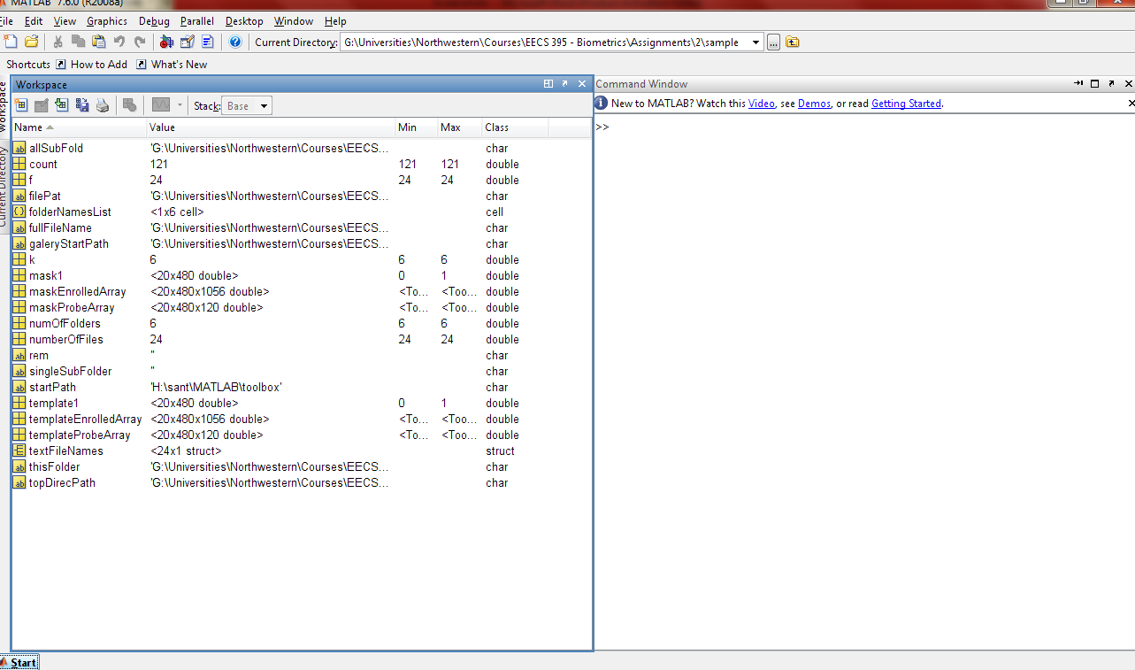

* We are comparing each image in the probe with all the images in the enrolled data base and then we are calculating the hamming distance for each of those images and getting the minimum value from the calculated hamming distance.
* Similarlly, we are the doing the above step for rest of the images and calculating the hamming distance for all the images selected in the probe.
* For this assignment, we have considered 10 folders from the gallery, 10 folders from the probe1 (LG 4000) and 10 folders from probe 2 (LG2200). Below are the folders that we have taken for calculating the hamming distance and plotting the distribution and roc curves.

**Gallery:**

* 02463
* 04233
* 04252
* 04261
* 04267
* 04327
* 04385
* 04394
* 04397
* 04470

**Probe1(LG4000):**

* 02463
* 04233
* 04470
* 0515
* 05268
* 05301
* 05393
* 05513
* 05555
* 05616

**Probe 2(LG2200):**

* 02463
* 04233
* 04327
* 04385
* 05669
* 05733
* 05752
* 05766
* 05774
* 05805
* We used Libor Maesk’s open source iris recognition software to segment the image and finding the hamming distance.
* The segmented image and their conversion to polar image is shown below

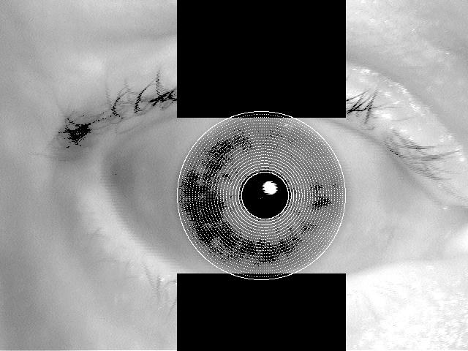

Fig 1: Finding the iris

**C:\Users\Karan\Desktop\MS\Biometrics\Assignment 2\LG2200-2008-03-11_13\2008-03-11_13\02463\02463d1914.tiff-polar.jpg**

Fig 2: Polar image

**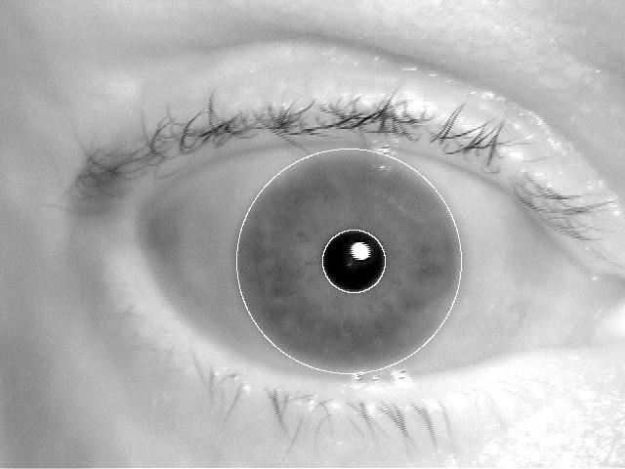**

Fig 3: Segmented image

* Below are the hamming distance calculated for the 10 different subjects with enrolled images in the database.

**LG4000(Probe1) with LG2200(Gallery)**

|  |  |  |  |  |  |  |  |  |  |  |
| --- | --- | --- | --- | --- | --- | --- | --- | --- | --- | --- |
| Hamming Distance between gallery and probe 1 | | | | | | | | | | |
|  | S1 | S2 | S3 | S4 | S5 | S6 | S7 | S8 | S9 | S10 |
| P1 | 0.408903 | 0.438021 | 0.378378 | 0.25 | 0.451574 | 0.478587 | 0.436333 | 0.23 | 0.445055 | 0.411765 |
| P2 | 0.353801 | 0.359155 | 0.294118 | 0.277778 | 0.358333 | 0.425355 | 0.344828 | 0.323529 | 0 | 0.303571 |
| P3 | 0.373457 | 0.354545 | 0.321429 | 0.3 | 0.235294 | 0.433333 | 0.166667 | 0.324561 | 0.2 | 0.377778 |
| P4 | 0.309211 | 0.423077 | 0.38141 | 0.208333 | 0.25 | 0.407095 | 0.294118 | 0.14 | 0.328221 | 0.290323 |
| P5 | 0.334656 | 0.462709 | 0.419301 | 0.388889 | 0.340164 | 0.396164 | 0.413793 | 0.233333 | 0.451389 | 0.166667 |
| P6 | 0.384615 | 0.380658 | 0.25 | 0.25 | 0.373606 | 0.396552 | 0.258929 | 0.125 | 0 | 0.357143 |
| P7 | 0.434483 | 0.358711 | 0.35159 | 0.368421 | 0.375 | 0.415985 | 0.348673 | 0.397606 | 0.295455 | 0.327731 |
| P8 | 0.418667 | 0.166667 | 0.205882 | 0.166667 | 0.208333 | 0.388889 | 0.235294 | 0.285714 | 0.25 | 0.333333 |
| P9 | 0.340909 | 0.291209 | 0.375 | 0.083333 | 0.245098 | 0.285714 | 0.333333 | 0 | 0.238095 | 0.256098 |
| P10 | 0.384106 | 0.37037 | 0.351632 | 0.285714 | 0.370219 | 0.42492 | 0.389706 | 0.230769 | 0 | 0.413377 |

**LG2200(Probe2) with LG2200(Gallery)**

|  |  |  |  |  |  |  |  |  |  |  |
| --- | --- | --- | --- | --- | --- | --- | --- | --- | --- | --- |
| Hamming Distance between gallery and probe 2 | | | | | | | | | | |
|  | S1 | S2 | S3 | S4 | S5 | S6 | S7 | S8 | S9 | S10 |
| P1 | 0.315728 | 0.404558 | 0.43241 | 0.34375 | 0.365385 | 0.414395 | 0.436333 | 0.346154 | 0.404891 | 0.37069 |
| P2 | 0.356643 | 0.344186 | 0.34106 | 0.205882 | 0.227273 | 0.371134 | 0.333333 | 0.160714 | 0.318182 | 0.356667 |
| P3 | 0.434532 | 0.440059 | 0.31667 | 0.329787 | 0.332335 | 0.396995 | 0.410465 | 0.295445 | 0.400262 | 0.385475 |
| P4 | 0.311111 | 0.400709 | 0.378906 | 0.2 | 0.3125 | 0.406893 | 0.355597 | 0.25 | 0.33871 | 0.242574 |
| P5 | 0.399554 | 0.407971 | 0.371429 | 0.3 | 0.415966 | 0.456117 | 0.410526 | 0.314815 | 0.444954 | 0.364286 |
| P6 | 0.301136 | 0.306122 | 0.25 | 0.185714 | 0.263158 | 0.19403 | 0.083333 | 0.066667 | 0.289256 | 0.227273 |
| P7 | 0.456705 | 0.464554 | 0.482036 | 0.468963 | 0.414474 | 0.473162 | 0.424658 | 0.410714 | 0.434055 | 0.433476 |
| P8 | 0.304878 | 0.359903 | 0.334158 | 0.40625 | 0.390909 | 0.353846 | 0.401639 | 0.25 | 0 | 0.355263 |
| P9 | 0.414802 | 0.382831 | 0.25 | 0.266667 | 0.443787 | 0.459101 | 0.425656 | 0.428571 | 0.462898 | 0.35034 |
| P10 | 0.408795 | 0.375758 | 0.297297 | 0.3 | 0.354331 | 0.406814 | 0.371795 | 0.368421 | 0.376923 | 0.375 |

**Histogram of Probe1 - LG 4000 - 2010**

Histogram for 10 by 10 matrix calculated from 10 different subjects with 120 enrolled data.

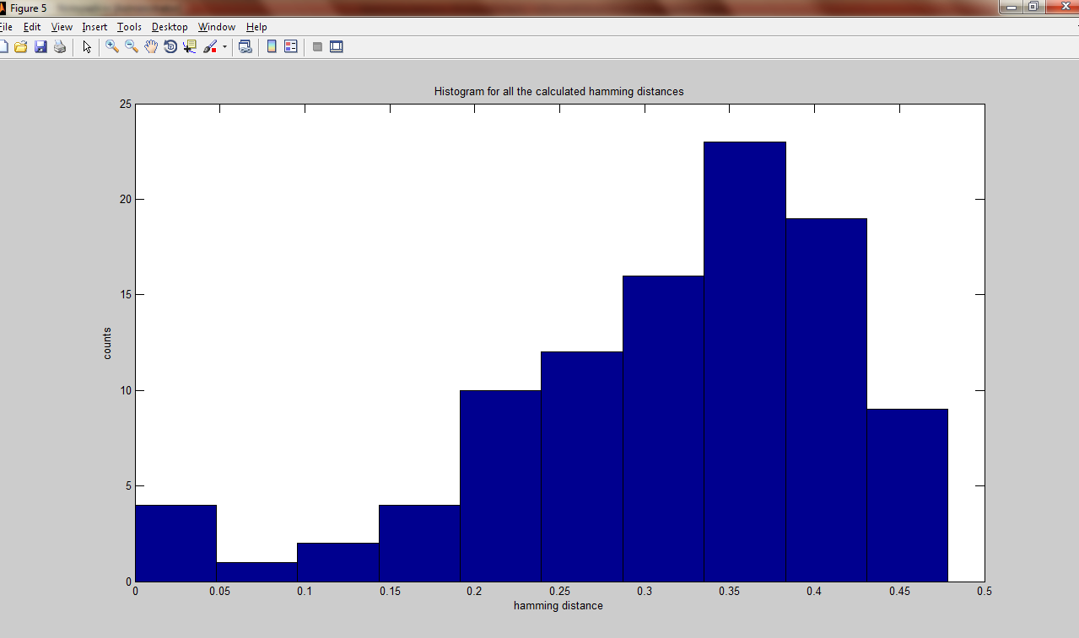

Authentic/Impostor Histogram by fixing the threshold at 0.2

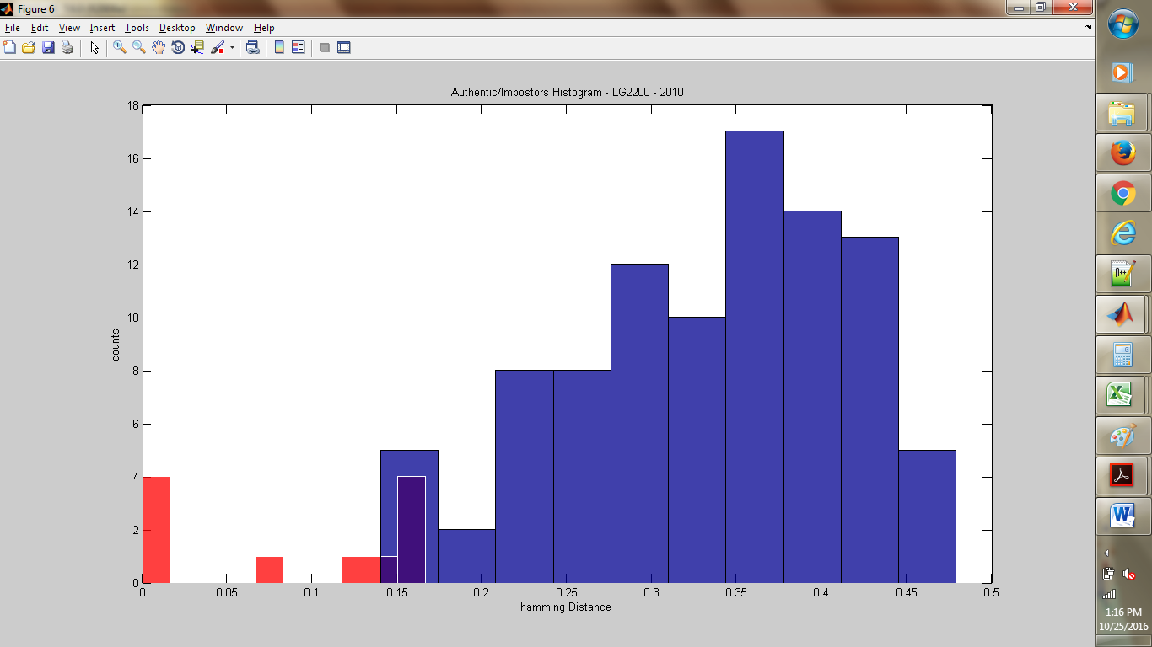

**MatlabCode for the Histogram for Probe1 and Probe2:**

probeout = a(:);

authentic = probeout(probeout < 0.2);

impostor = probeout(probeout > 0.2);

Figure(1)

hist(authentic);

h = findobj(gca,'Type','patch');

set(h,'FaceColor','r','EdgeColor','w')

hold on

hist(impostor)

h = findobj(gca,'Type','patch');

set(h);

ylabel('counts');

xlabel('hamming Distance');

title('Authentic/Impostors Histogram - LG2200 - 2010');

**Probe 2 – Authentic/Impostors Histogram of LG2200**

probeout = b(:);

authentic = probeout(probeout < 0.2);

impostor = probeout(probeout > 0.2);

Figure(1)

hist(authentic);

h = findobj(gca,'Type','patch');

set(h,'FaceColor','r','EdgeColor','w')

hold on

hist(impostor)

h = findobj(gca,'Type','patch');

set(h);

ylabel('counts');

xlabel('hamming Distance');

title('Authentic/Impostors Histogram - LG2200 - 2010');

**Histogram of Probe1 - LG 2200 - 2010**

Histogram for 10 by 10 matrix calculated from 10 different subjects with 120 enrolled data.

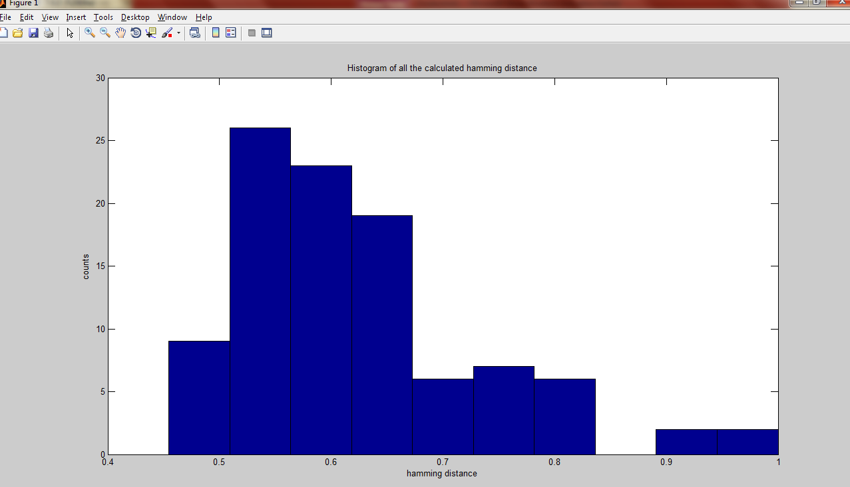

Authentic/Impostor Histogram by fixing the threshold at 0.2

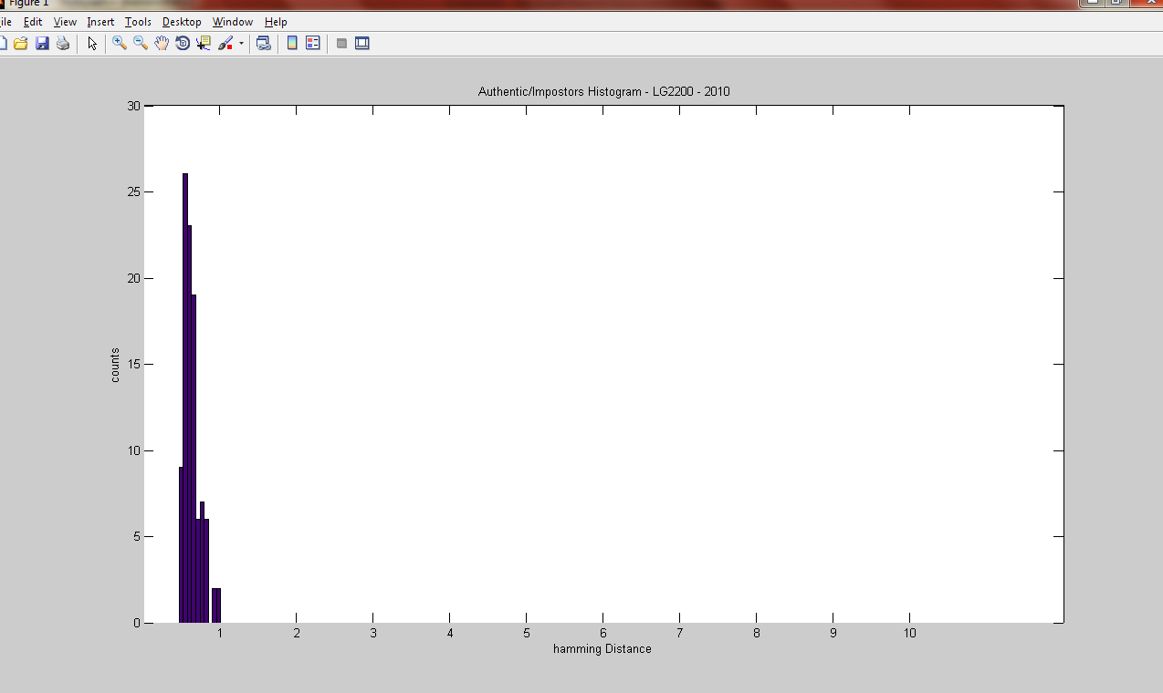

* In probe 2 (LG2200), we can see the hamming distance of the images is coming as greater than 0.5 as we haven’t selected any similar folders that are present in the gallery.

3. ROC Curve - Since we have the threshold at 0.2 and there are no overlapping between authentic and impostor distribution, we will get a perfect roc curve. For both the probes, we are generating a perfect system.

Threshold = 0.2

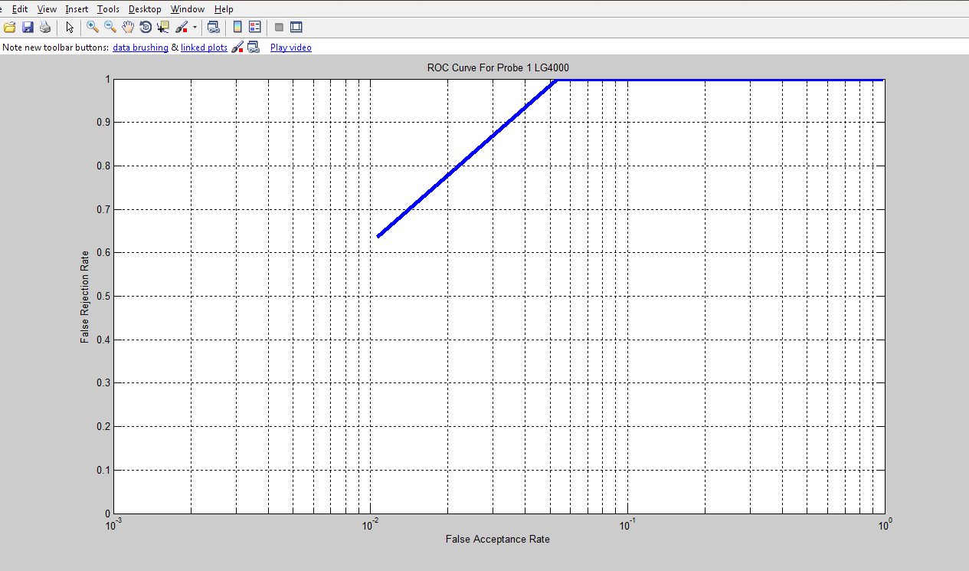

Threshold 0.3

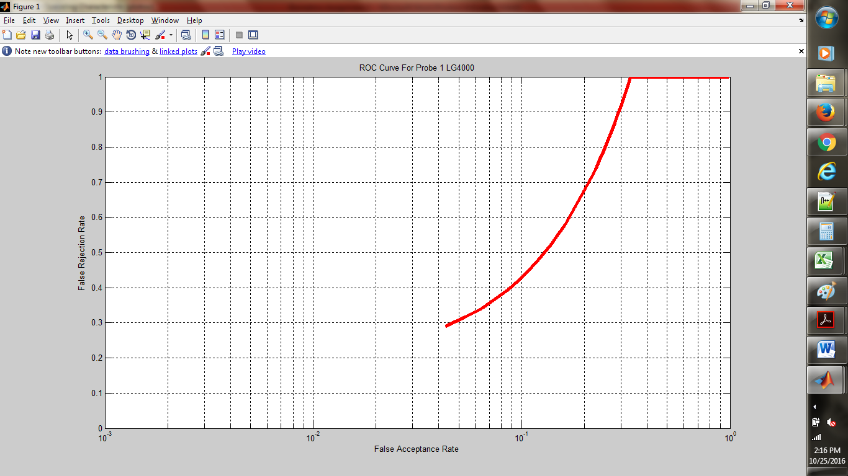

Plot for both the thresholds

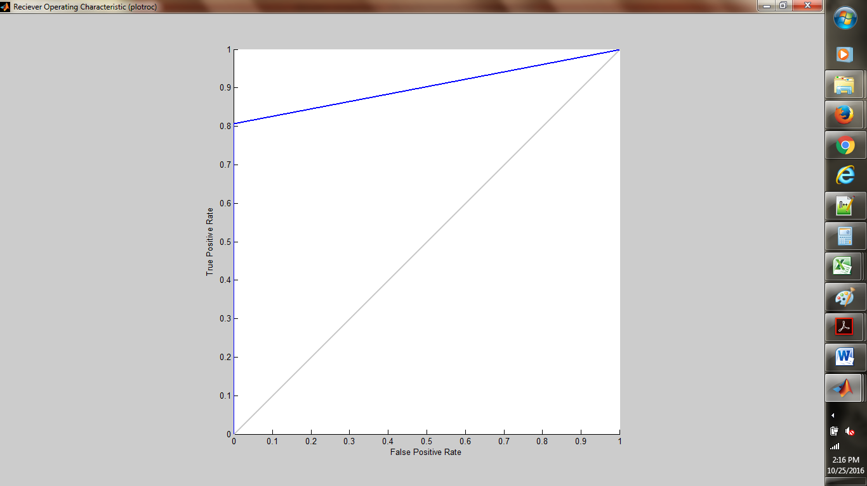

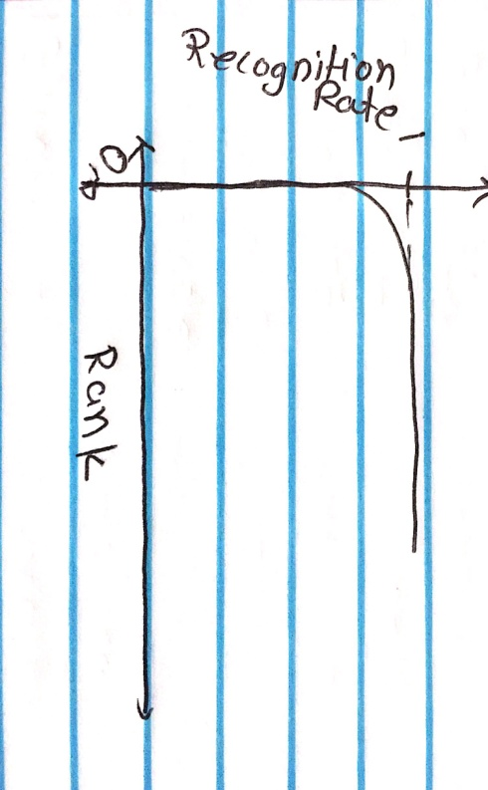

4. CMC Curve: For the CMC curve, we find the probability of the match score. As we are getting the highest accuracy the CMC curve is as follow

**Discussions:**

1. We can use clustering technique to find the authentic and impostor matrix
2. We can use more images that can be enrolled in the gallery and program the system to use it in an efficient way.
3. Minimize the time complexity of the algorithm by generating more database that are dynamic.